MD

**Note : Please add your feedback in red colour. Thank you**

**#01 - ECIDINING PDF EXTRACTION**

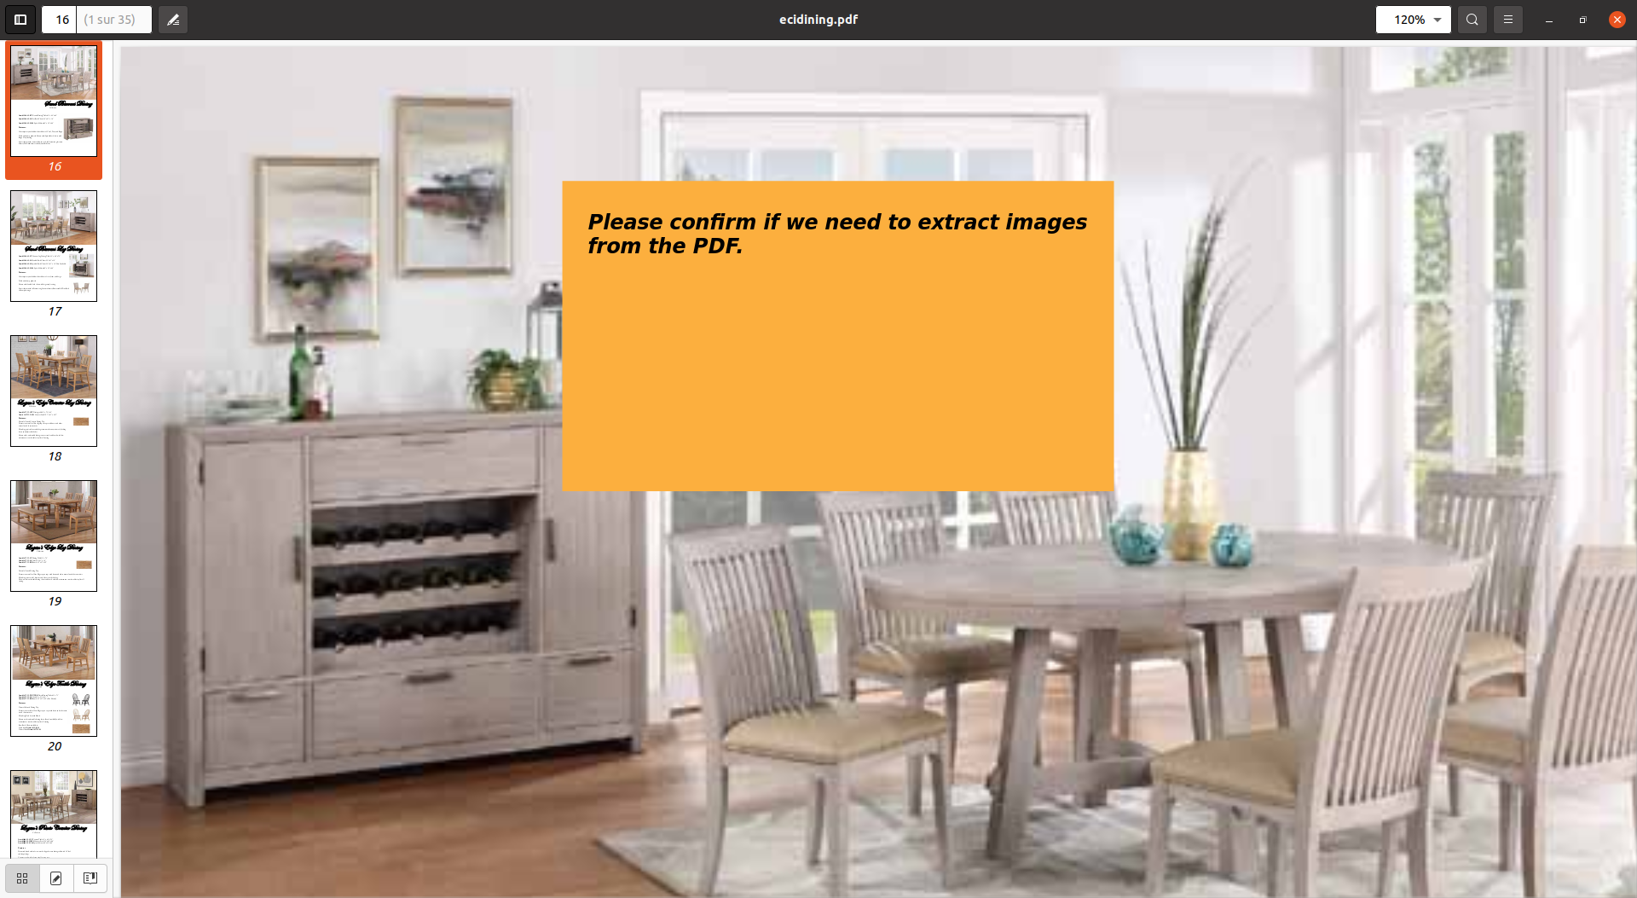

**Response :**

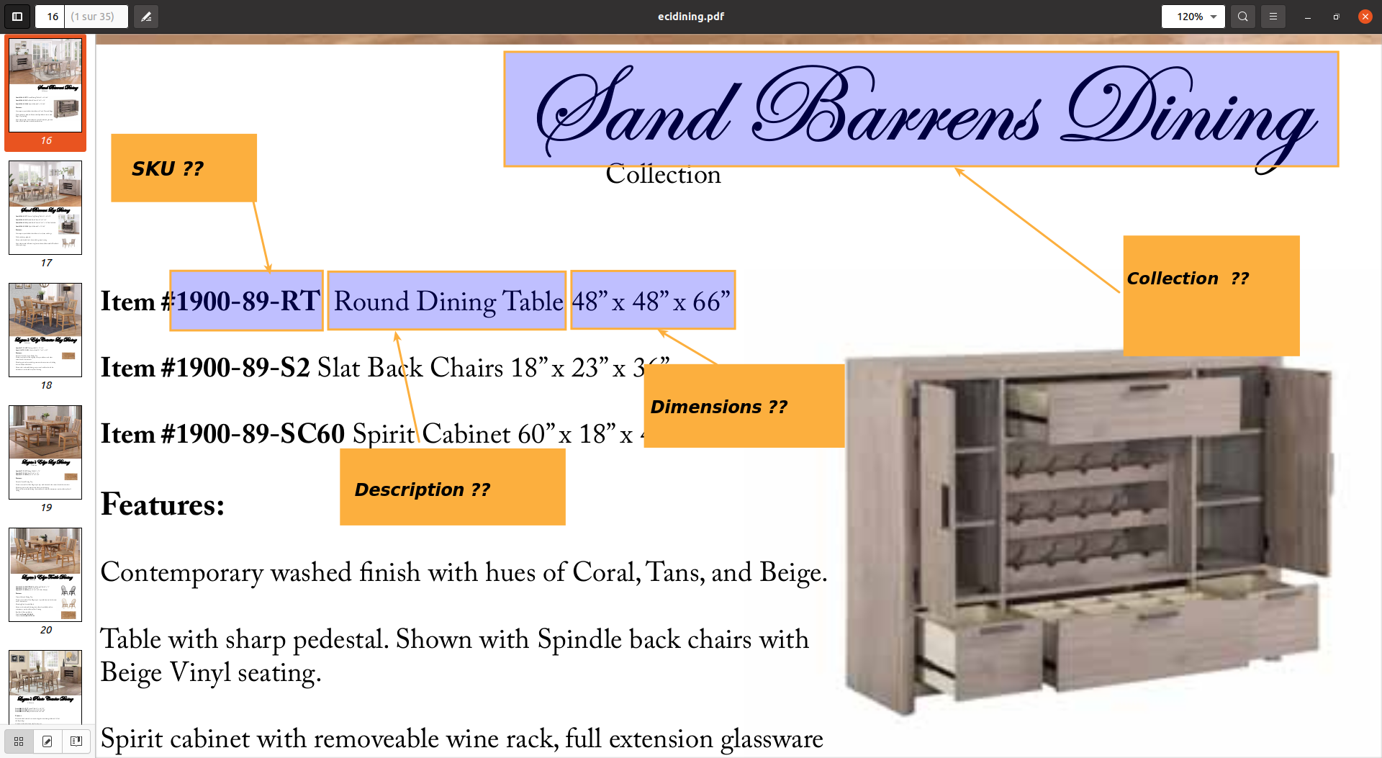

**Response :**

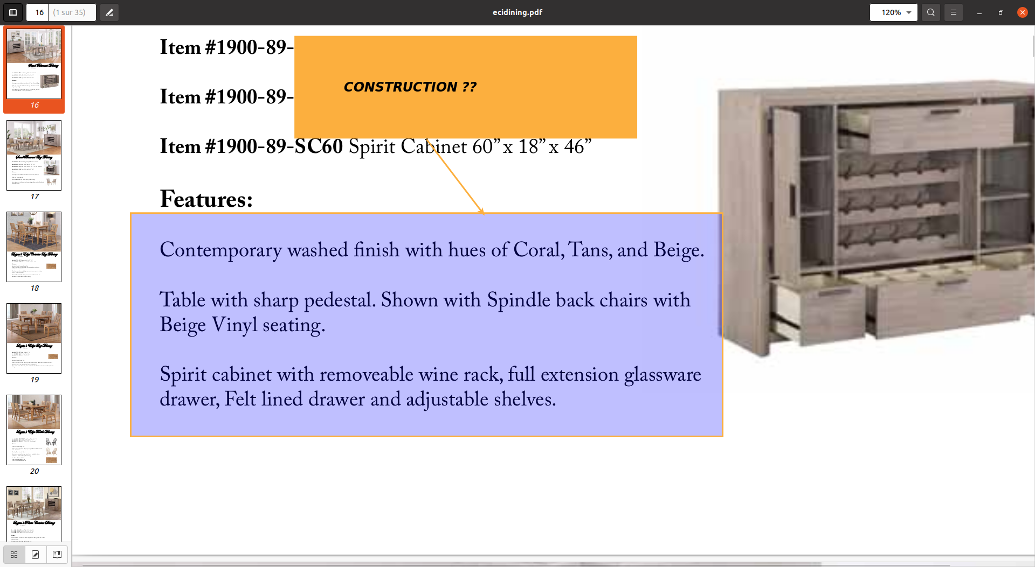

**Response :**

**#02 - Carmet Catalog Page pdf extraction**

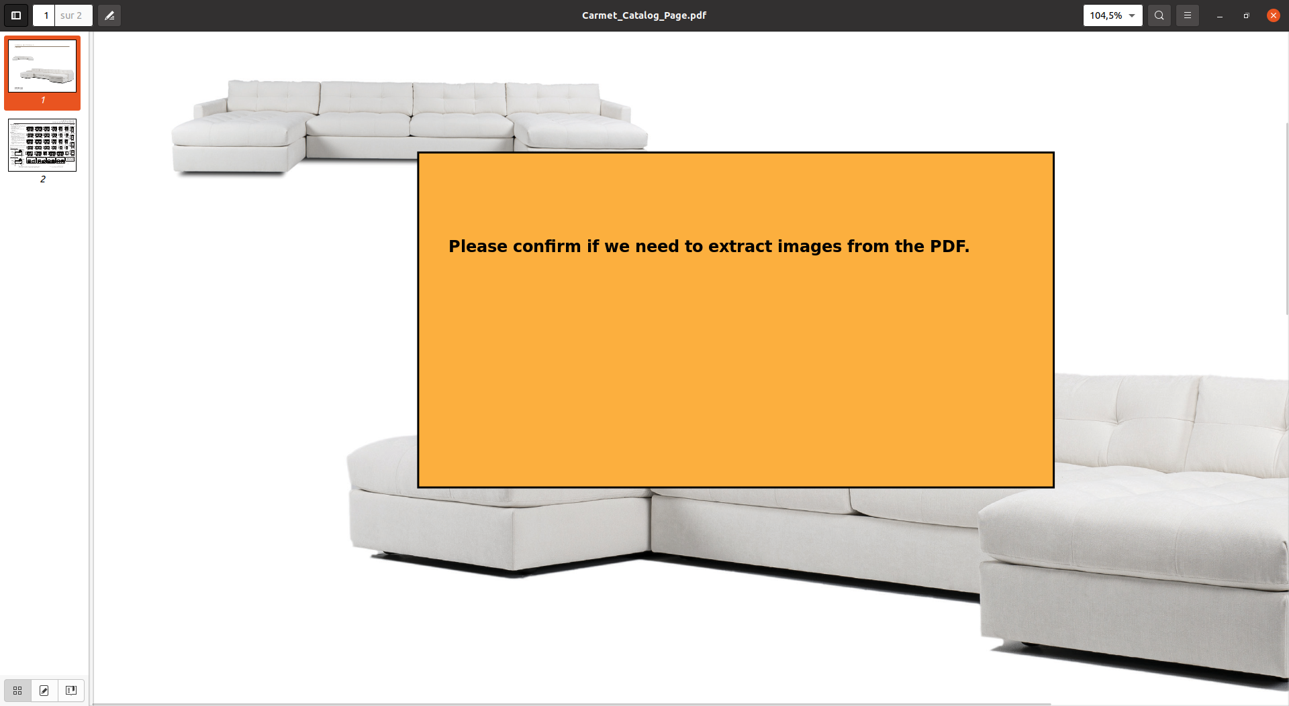

**Response :**

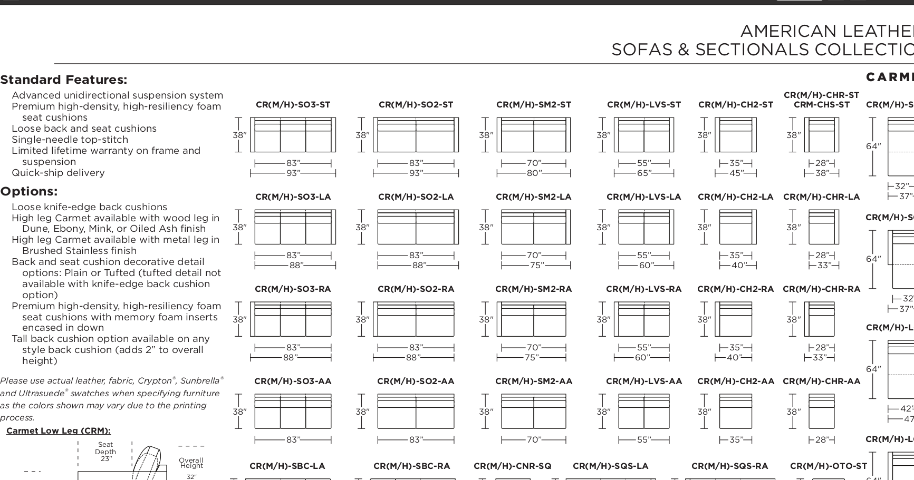

**From this page, should we extract only the standard features text as construction and the options text as additional info? If any other information from this page is required, please notify us**

**Response :**

**#03 - Revised MD attribute template**

**Website :** <https://www.mavinfurniture.com>

**Do we need to complete the sample template with information that we can extract from each product link page?**

**Response :**

**#04 - I suppose the answer is yes to the previous question. Here are my concerns about data labeling on the website.**

* **Product link :** [**https://www.mavinfurniture.com/products/chairs/dallas/**](https://www.mavinfurniture.com/products/chairs/dallas/)

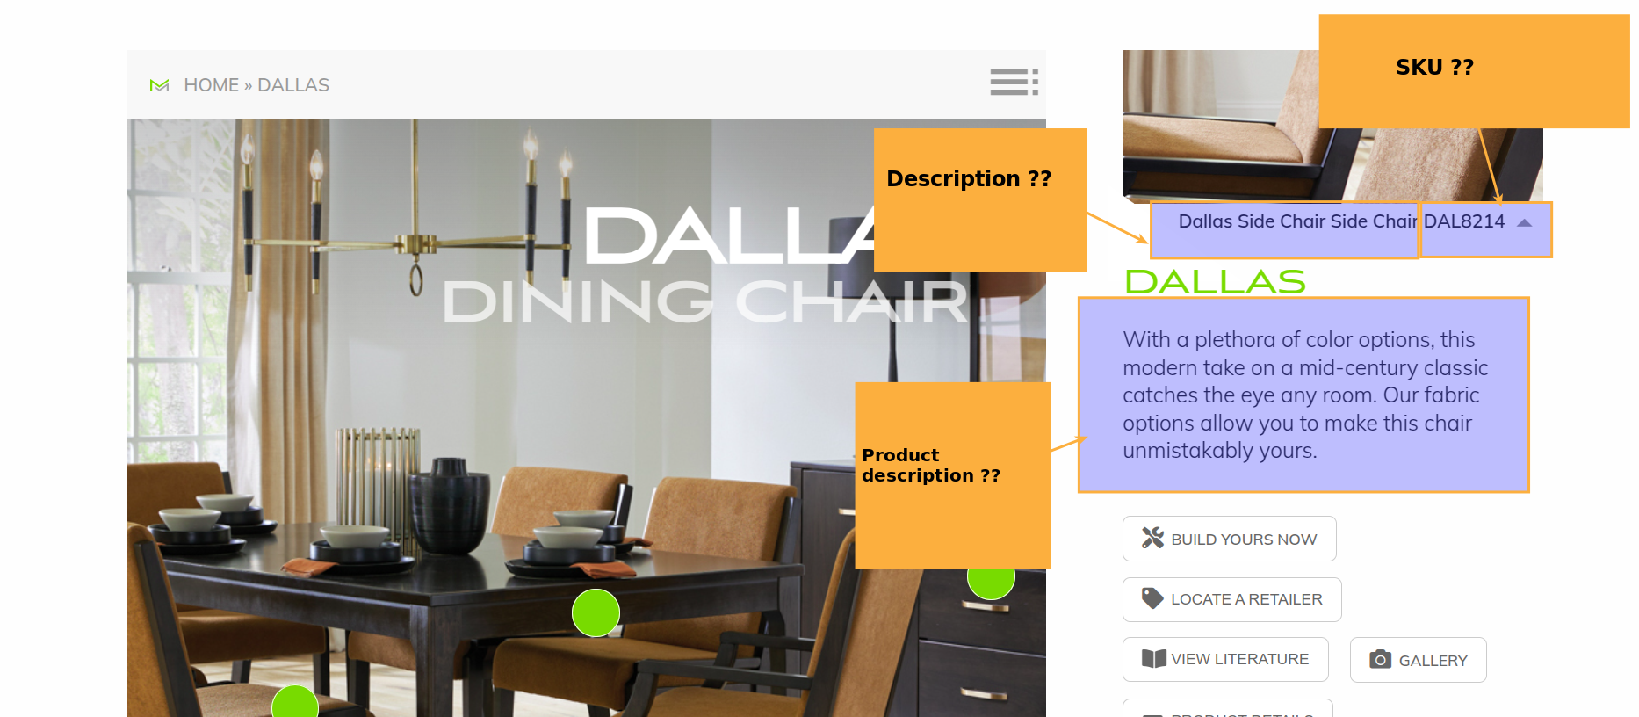

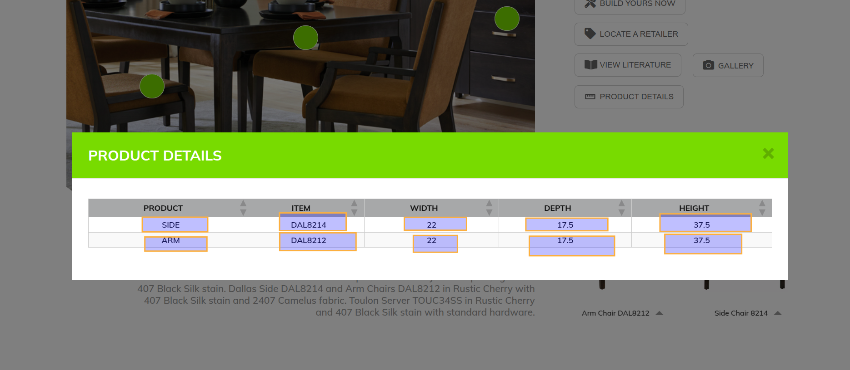

Response :

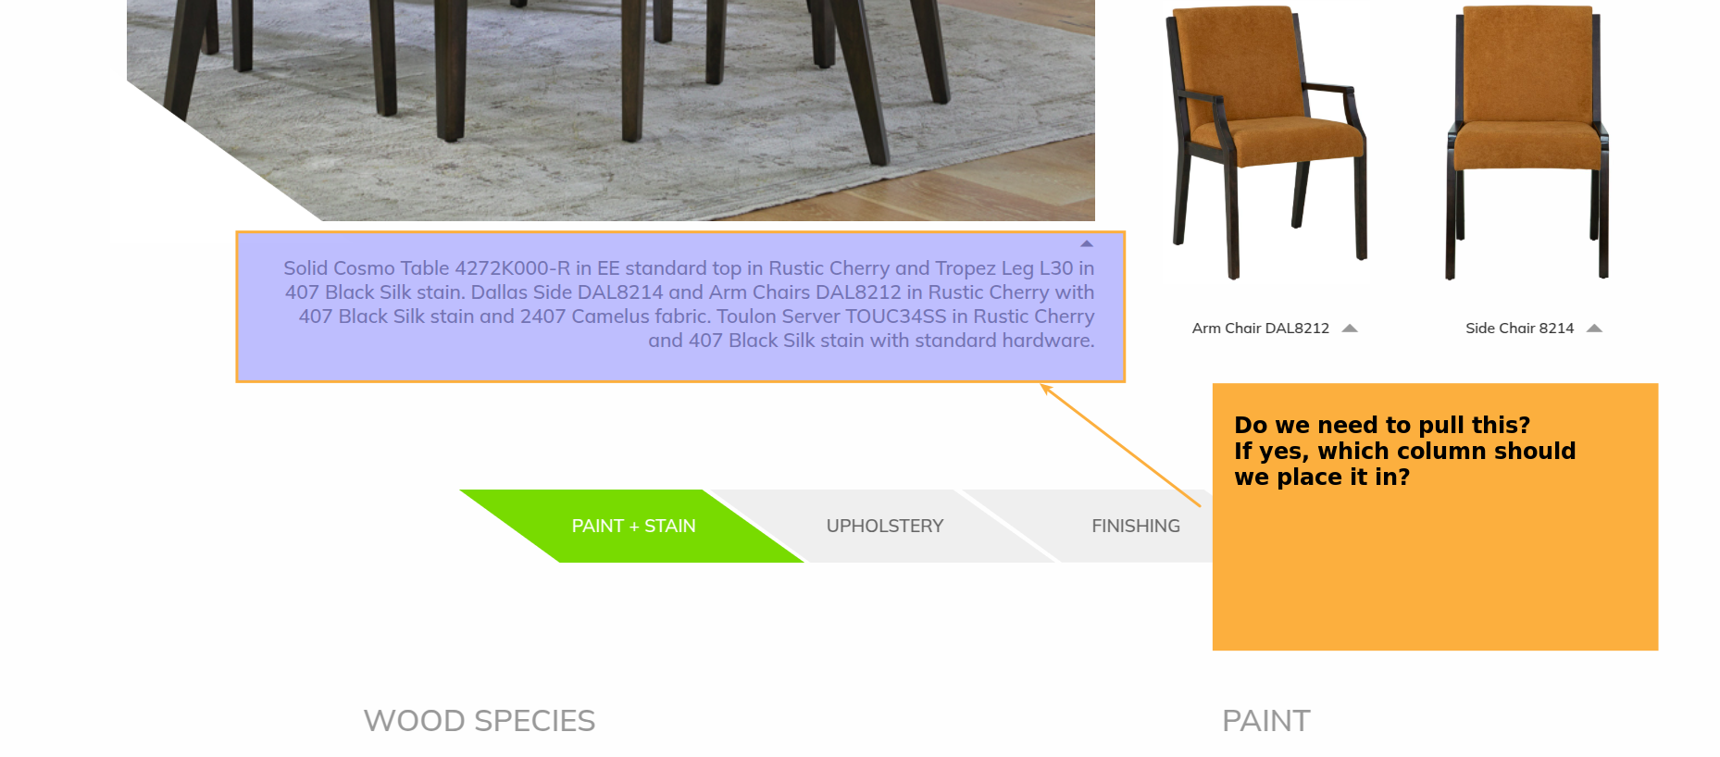

Response :

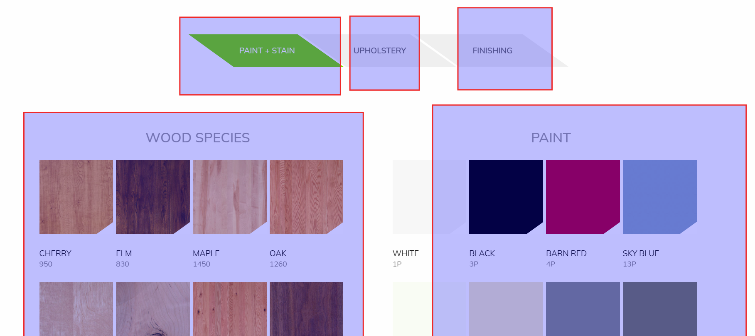

Response :